JAVA LAB EVALUATION

**CB.SC.I5DAS21126**

**GUHAN C**

**Question number :17**

Given a set of phone numbers Jones has to reverse the digit of those phone numbers and generate new phone numbers.

Constraint

1<=n<=100

Input format:

First line contains number of test cases

Followed by phone numbers

Output format:

Reversed digits of n phone numbers in separate lines

**Code:**

import java.util.Arrays;

/*

* Click nbfs://nbhost/SystemFileSystem/Templates/Licenses/license-default.txt to change this license

* Click nbfs://nbhost/SystemFileSystem/Templates/GUIForms/JFrame.java to edit this template

*/

/**

*

* @author cvgms

*/

public class eval extends javax.swing.JFrame {

/**

* Creates new form eval

*/

public eval() {

initComponents();

}

/**

* This method is called from within the constructor to initialize the form.

* WARNING: Do NOT modify this code. The content of this method is always

* regenerated by the Form Editor.

*/

@SuppressWarnings("unchecked")

// <editor-fold defaultstate="collapsed" desc="Generated Code">

private void initComponents() {

jTextField1 = new javax.swing.JTextField();

jLabel1 = new javax.swing.JLabel();

jLabel2 = new javax.swing.JLabel();

jButton1 = new javax.swing.JButton();

jLabel3 = new javax.swing.JLabel();

jScrollPane1 = new javax.swing.JScrollPane();

jTextArea1 = new javax.swing.JTextArea();

jScrollPane2 = new javax.swing.JScrollPane();

jTextArea2 = new javax.swing.JTextArea();

setDefaultCloseOperation(javax.swing.WindowConstants.EXIT_ON_CLOSE);

jLabel1.setText("Enter No of Phone numbers");

jLabel2.setText("Enter the phone numbers");

jButton1.setText("Submit");

jButton1.addActionListener(new java.awt.event.ActionListener() {

public void actionPerformed(java.awt.event.ActionEvent evt) {

jButton1ActionPerformed(evt);

}

});

jLabel3.setText("Answer");

jTextArea1.setColumns(20);

jTextArea1.setRows(5);

jScrollPane1.setViewportView(jTextArea1);

jTextArea2.setColumns(20);

jTextArea2.setRows(5);

jScrollPane2.setViewportView(jTextArea2);

javax.swing.GroupLayout layout = new javax.swing.GroupLayout(getContentPane());

getContentPane().setLayout(layout);

layout.setHorizontalGroup(

layout.createParallelGroup(javax.swing.GroupLayout.Alignment.LEADING)

.addGroup(layout.createSequentialGroup()

.addGap(38, 38, 38)

.addGroup(layout.createParallelGroup(javax.swing.GroupLayout.Alignment.LEADING)

.addGroup(layout.createSequentialGroup()

.addComponent(jLabel1, javax.swing.GroupLayout.PREFERRED_SIZE, 165, javax.swing.GroupLayout.PREFERRED_SIZE)

.addGap(18, 18, 18)

.addComponent(jTextField1, javax.swing.GroupLayout.PREFERRED_SIZE, 71, javax.swing.GroupLayout.PREFERRED_SIZE))

.addGroup(layout.createSequentialGroup()

.addGroup(layout.createParallelGroup(javax.swing.GroupLayout.Alignment.LEADING)

.addComponent(jLabel2, javax.swing.GroupLayout.PREFERRED_SIZE, 133, javax.swing.GroupLayout.PREFERRED_SIZE)

.addGroup(layout.createSequentialGroup()

.addGap(29, 29, 29)

.addComponent(jLabel3, javax.swing.GroupLayout.PREFERRED_SIZE, 63, javax.swing.GroupLayout.PREFERRED_SIZE)))

.addGap(18, 18, 18)

.addGroup(layout.createParallelGroup(javax.swing.GroupLayout.Alignment.LEADING)

.addGroup(layout.createSequentialGroup()

.addComponent(jScrollPane1, javax.swing.GroupLayout.PREFERRED_SIZE, javax.swing.GroupLayout.DEFAULT_SIZE, javax.swing.GroupLayout.PREFERRED_SIZE)

.addGap(35, 35, 35)

.addComponent(jButton1))

.addComponent(jScrollPane2, javax.swing.GroupLayout.PREFERRED_SIZE, javax.swing.GroupLayout.DEFAULT_SIZE, javax.swing.GroupLayout.PREFERRED_SIZE))))

.addContainerGap(81, Short.MAX_VALUE))

);

layout.setVerticalGroup(

layout.createParallelGroup(javax.swing.GroupLayout.Alignment.LEADING)

.addGroup(layout.createSequentialGroup()

.addGap(19, 19, 19)

.addGroup(layout.createParallelGroup(javax.swing.GroupLayout.Alignment.BASELINE)

.addComponent(jLabel1, javax.swing.GroupLayout.PREFERRED_SIZE, 22, javax.swing.GroupLayout.PREFERRED_SIZE)

.addComponent(jTextField1))

.addGroup(layout.createParallelGroup(javax.swing.GroupLayout.Alignment.LEADING)

.addGroup(layout.createSequentialGroup()

.addGap(45, 45, 45)

.addComponent(jLabel2, javax.swing.GroupLayout.PREFERRED_SIZE, 42, javax.swing.GroupLayout.PREFERRED_SIZE))

.addGroup(layout.createSequentialGroup()

.addGap(35, 35, 35)

.addComponent(jScrollPane1, javax.swing.GroupLayout.PREFERRED_SIZE, javax.swing.GroupLayout.DEFAULT_SIZE, javax.swing.GroupLayout.PREFERRED_SIZE))

.addGroup(layout.createSequentialGroup()

.addGap(49, 49, 49)

.addComponent(jButton1)))

.addGroup(layout.createParallelGroup(javax.swing.GroupLayout.Alignment.LEADING)

.addGroup(layout.createSequentialGroup()

.addGap(87, 87, 87)

.addComponent(jLabel3, javax.swing.GroupLayout.PREFERRED_SIZE, 37, javax.swing.GroupLayout.PREFERRED_SIZE))

.addGroup(layout.createSequentialGroup()

.addGap(59, 59, 59)

.addComponent(jScrollPane2, javax.swing.GroupLayout.PREFERRED_SIZE, javax.swing.GroupLayout.DEFAULT_SIZE, javax.swing.GroupLayout.PREFERRED_SIZE)))

.addContainerGap(69, Short.MAX_VALUE))

);

pack();

}// </editor-fold>

private void jButton1ActionPerformed(java.awt.event.ActionEvent evt) {

// TODO add your handling code here:

int n= Integer.parseInt(jTextField1.getText());

if(n>100 || n <1){

JOptionPane.showMessageDialog(null,"Not valid n");

}

else{

String b[] =jTextArea1.getText().split("\n");

String a="";

String l="";

for (int i=0;i<n;i++){

String[] z=b[i].split("");

l="";

for (int j=7;j>=0;j--){

String m=z[j];

l=l+m;

}

a=a+l+"\n";

jTextArea2.setText(a);

}

}

} /**

* @param args the command line arguments

*/

public static void main(String args[]) {

/* Set the Nimbus look and feel */

//<editor-fold defaultstate="collapsed" desc=" Look and feel setting code (optional) ">

/* If Nimbus (introduced in Java SE 6) is not available, stay with the default look and feel.

* For details see http://download.oracle.com/javase/tutorial/uiswing/lookandfeel/plaf.html

*/

try {

for (javax.swing.UIManager.LookAndFeelInfo info : javax.swing.UIManager.getInstalledLookAndFeels()) {

if ("Nimbus".equals(info.getName())) {

javax.swing.UIManager.setLookAndFeel(info.getClassName());

break;

}

}

} catch (ClassNotFoundException ex) {

java.util.logging.Logger.getLogger(eval.class.getName()).log(java.util.logging.Level.SEVERE, null, ex);

} catch (InstantiationException ex) {

java.util.logging.Logger.getLogger(eval.class.getName()).log(java.util.logging.Level.SEVERE, null, ex);

} catch (IllegalAccessException ex) {

java.util.logging.Logger.getLogger(eval.class.getName()).log(java.util.logging.Level.SEVERE, null, ex);

} catch (javax.swing.UnsupportedLookAndFeelException ex) {

java.util.logging.Logger.getLogger(eval.class.getName()).log(java.util.logging.Level.SEVERE, null, ex);

}

//</editor-fold>

/* Create and display the form */

java.awt.EventQueue.invokeLater(new Runnable() {

public void run() {

new eval().setVisible(true);

}

});

}

// Variables declaration - do not modify

private javax.swing.JButton jButton1;

private javax.swing.JLabel jLabel1;

private javax.swing.JLabel jLabel2;

private javax.swing.JLabel jLabel3;

private javax.swing.JScrollPane jScrollPane1;

private javax.swing.JScrollPane jScrollPane2;

private javax.swing.JTextArea jTextArea1;

private javax.swing.JTextArea jTextArea2;

private javax.swing.JTextField jTextField1;

// End of variables declaration

}

**DESIGN:**

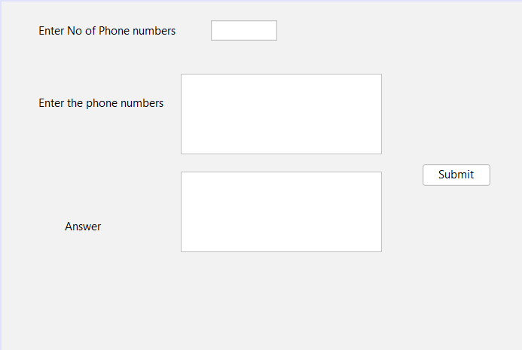

**OUTPUT:**

